Public Health Medicine Pandemic Experience survey

The survey was sent to all BMA members who list public health as an area of their work or specialty. The survey covered a range of topics, designed to build a picture of what the experience of the COVID-19 pandemic has been like for public health doctors and their views on the future of public health, especially in England.

The survey was sent to 1280 members. At the time of writing, 257 responses had been received, which equates to a 20% response rate.

This report focuses on respondents’ views on the re-organisation of public health in England.

Views on the reorganisation of Public Health England

One section of the survey asked a short series of questions around respondents’ attitudes to the reorganisation of Public Health England (PHE) and the creation of the National Institute for Health Protection (NIHP). We wanted to know specifically how they thought the changes would affect the public health response to the current – and future – pandemics, as well as work in the other domains of public health.

We also asked for their views on the level they felt able to contribute to the process and the independence of the future organisation.

Confidence in the independence of the NIHP

Overall, the preliminary survey data shows that there was very little confidence that the NIHP could be an independent body, and therefore be able to speak truth to power – nearly three-quarters (72%) of the respondents did not have confidence in its ability to speak truth to power.

Overall responses:
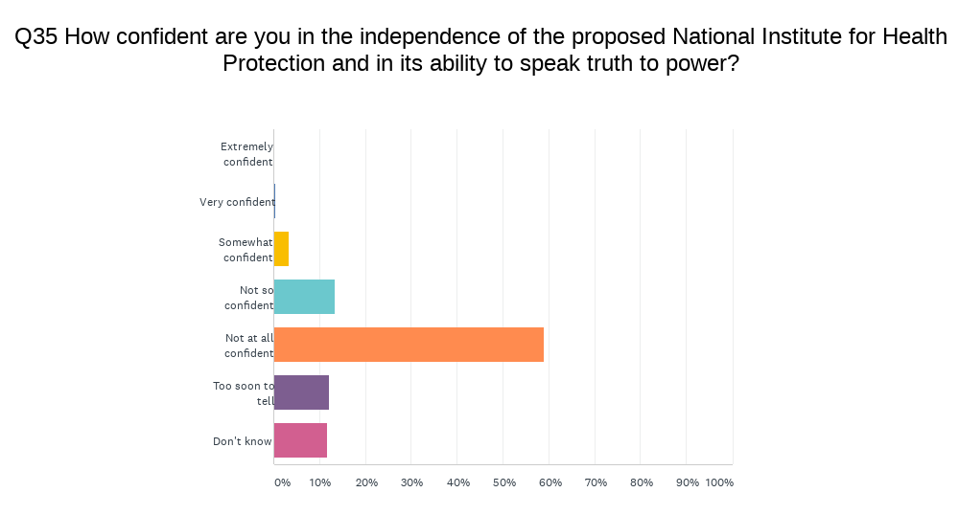

However, the isolated responses from PHE staff were even more damning, with 85% not confident that the new NIHP could be independent:
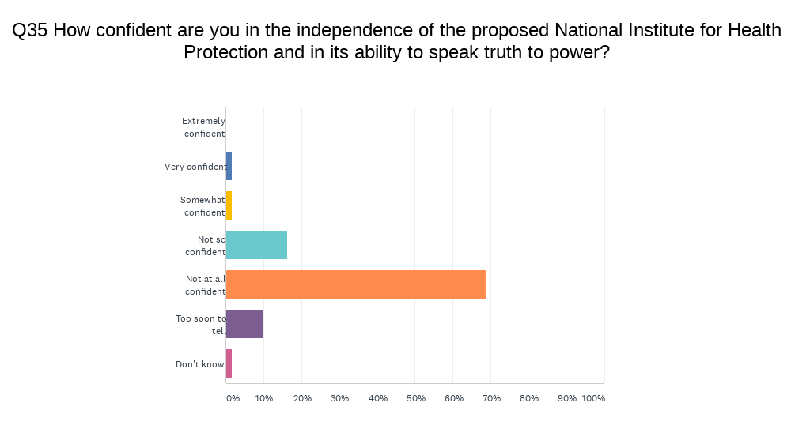

Effect on pandemic responses

The preliminary data show that 42% of respondents had a negative view of the affect the reorganisation will have on the response to the current pandemic. Over half (55%) of PHE staff who completed the survey considered that the reorganisation would worsen the response.

For future pandemic response, views were more cautious: almost half were uncertain what the change would mean, although the responses suggest that 40% are yet to be convinced that there will be an improvement.

Overall responses:
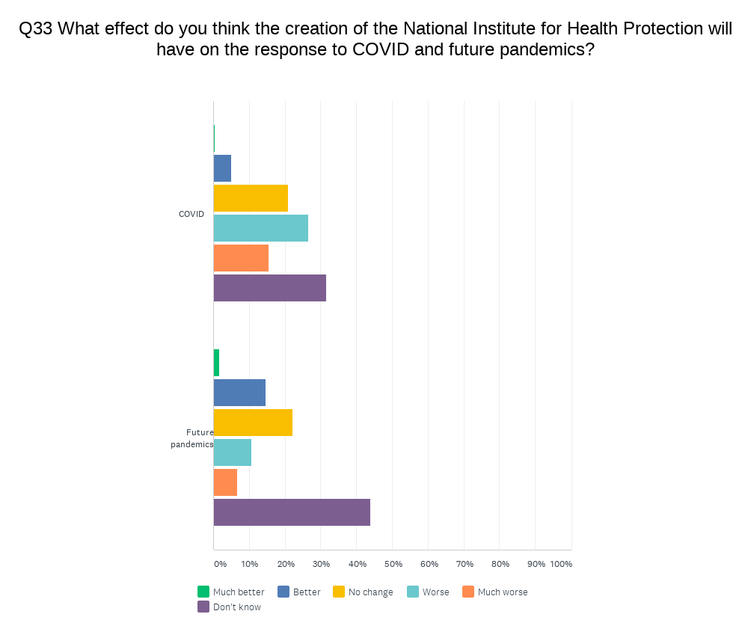

PHE staff responses:
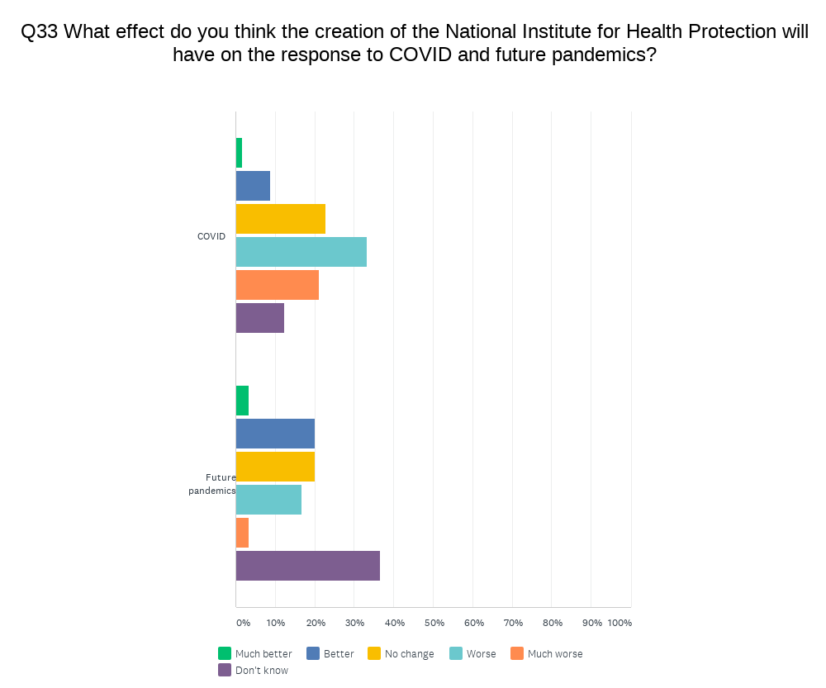
Public health areas away from pandemic responses

Even more worrying, 63% of the respondents indicated that the reorganisation would have a negative affect on the system’s ability to respond to other public health issues, and the response from PHE staff was even more negative, with 81% considering that it would have a negative effect.

Overall responses:
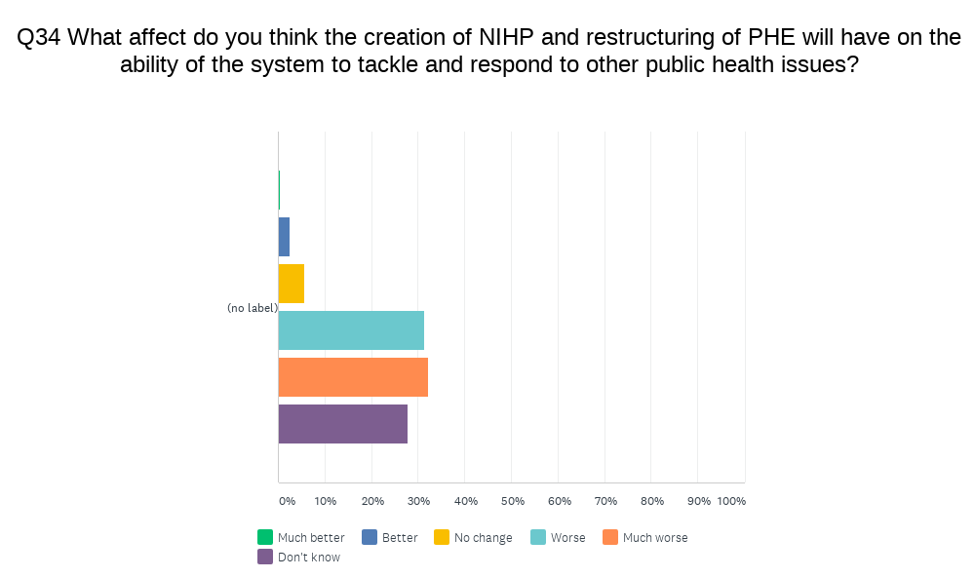

PHE staff responses:
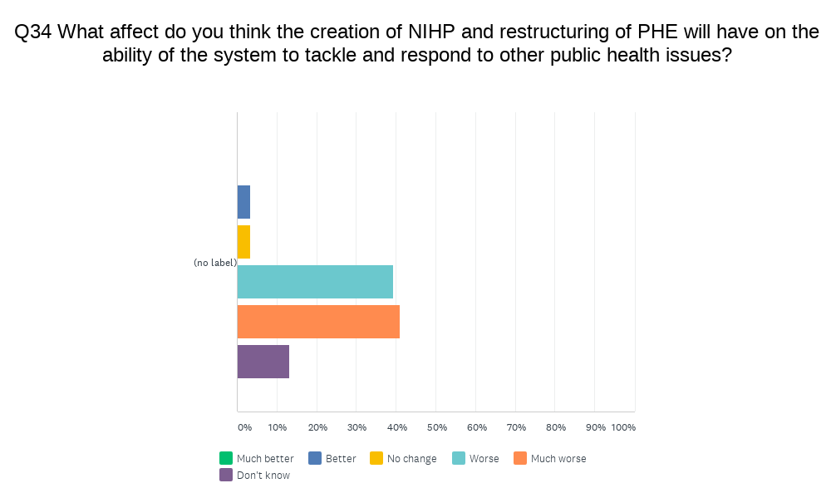
Ability to contribute to the process

With all this in mind it is, therefore, perhaps unsurprising but still of significant concern that well over half (61%) of respondents do not have any confidence in their ability to contribute to the development of the new public health system.

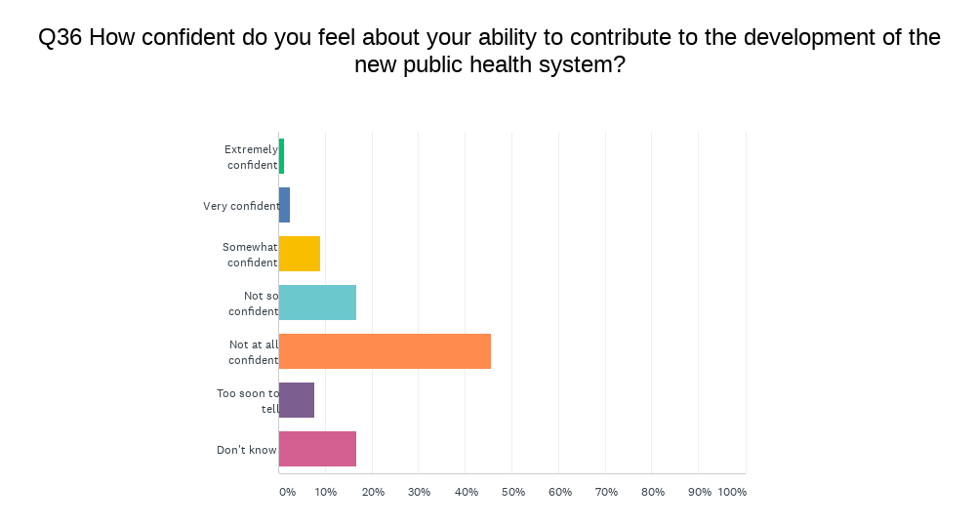

Despite the reassurances being given that PHE staff were being involved in the process, the negative feeling was even more pronounced in the responses from PHE staff, with 71% saying they were not confident. This does not seem to be a good place from which to build a successful organisation.

