- What are your biggest concerns for the health service this winter? Please rank your top three concerns.
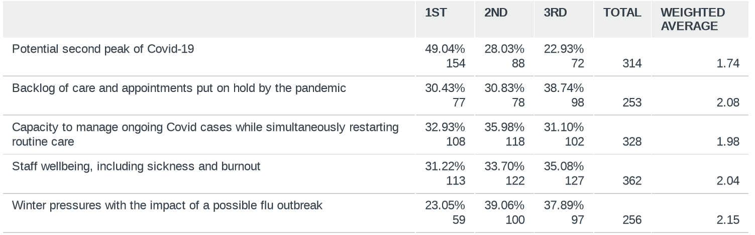

- Based on your personal experience and the latest data, how likely do you believe a second peak of Coronavirus will be in your nation during the next six months?
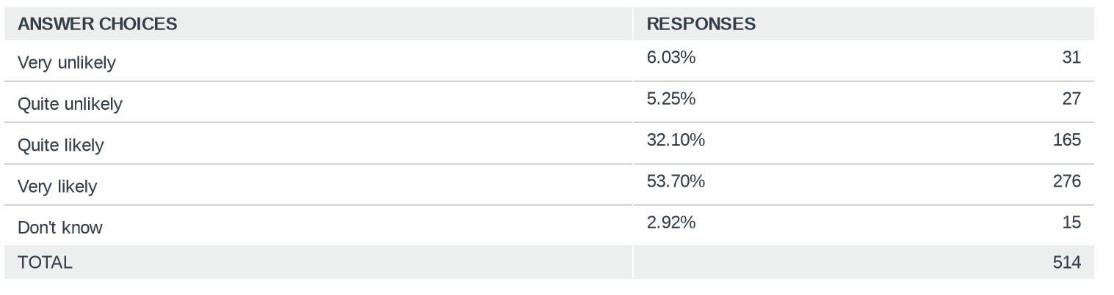

- To what extent do you agree or disagree that the following presents a risk of causing a second peak?
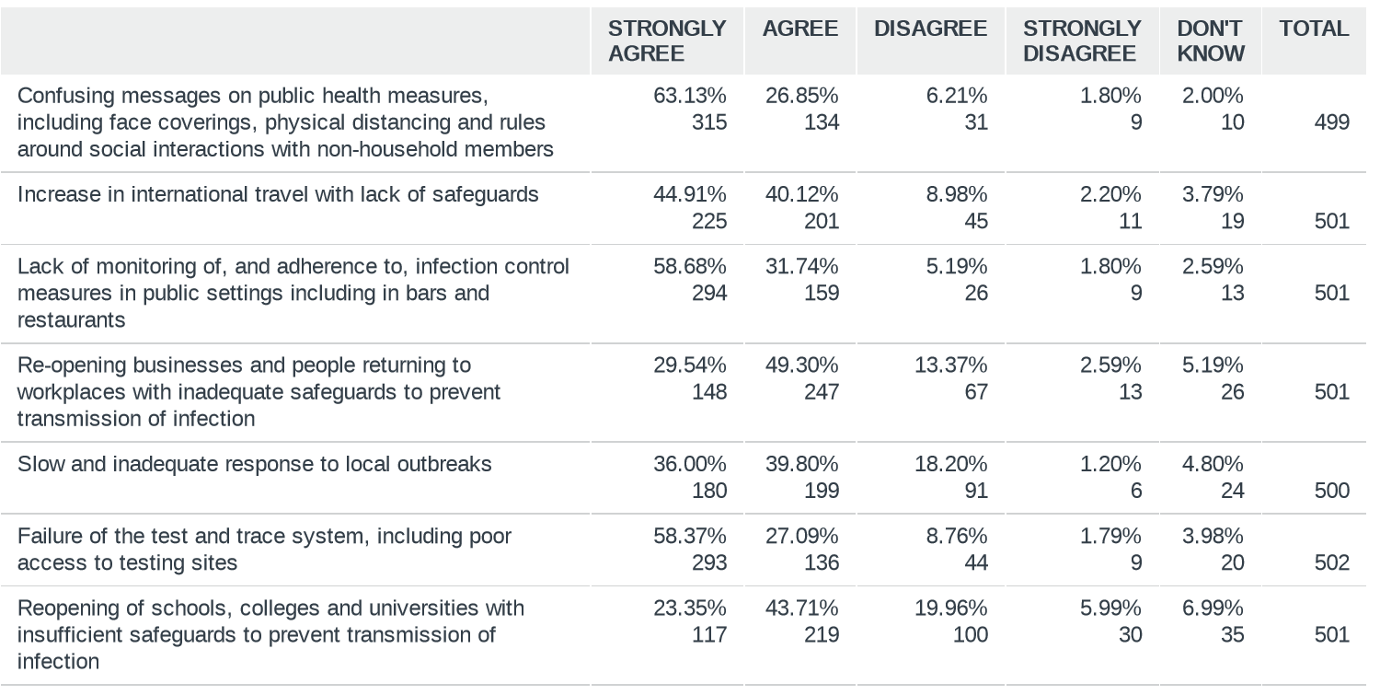
- In your opinion, what degree of impact might the following measures have in preventing a second peak?
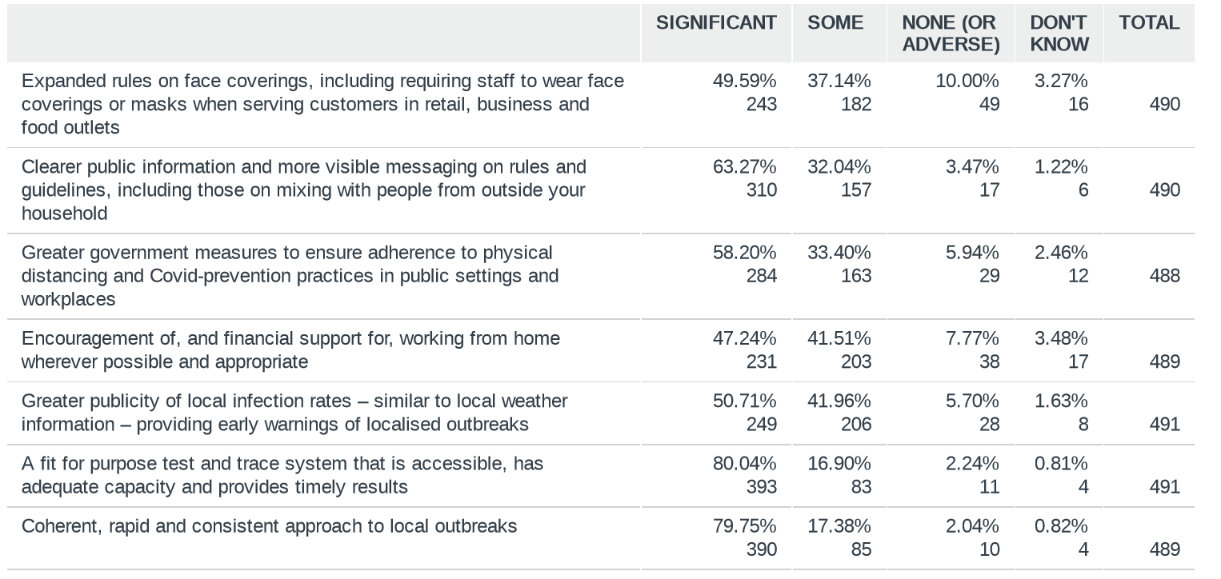
- What, in your opinion, should be the priorities to get the health service in your nation on to a sustainable footing over the next year? Please mark up to 4 priorities
